RESOLUTIONexpress Instruction Sheet

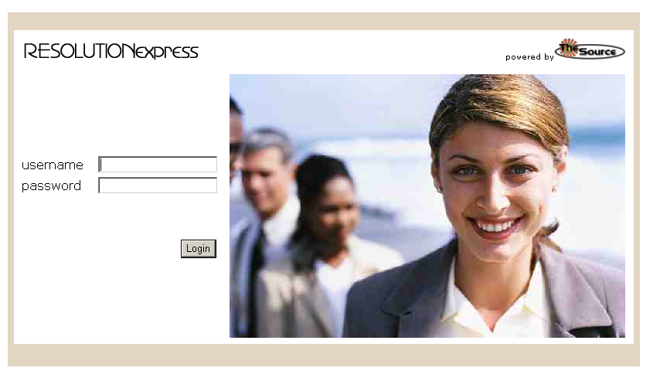
Log into RESOLUTIONexpress using your username and password. If you do not have a username and password, please call or email Jan Goerke at the WESD business office (503.385.4520, jan.goerke@wesd.org).

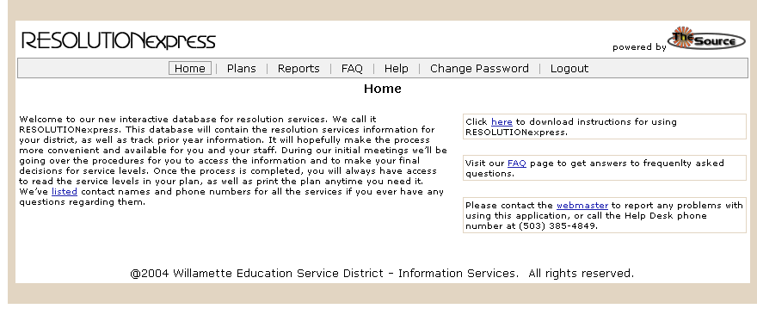
Once logged in you will first see the home screen. From here you can access other screens by choosing one of the menu options from the horizontal menu bar positioned along the top of the screen. To go to the Plans screen click on Plans, to go to the Reports screen click on Reports, and so on.

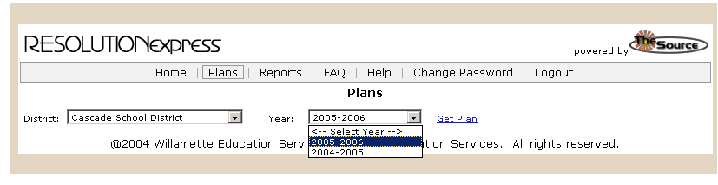
Once at the Plans screen you will be prompted to choose the school district and year of the Resolution Plan you would like to access. Once you have chosen a school district and year, click the “Get Plan” link to bring up that plan.

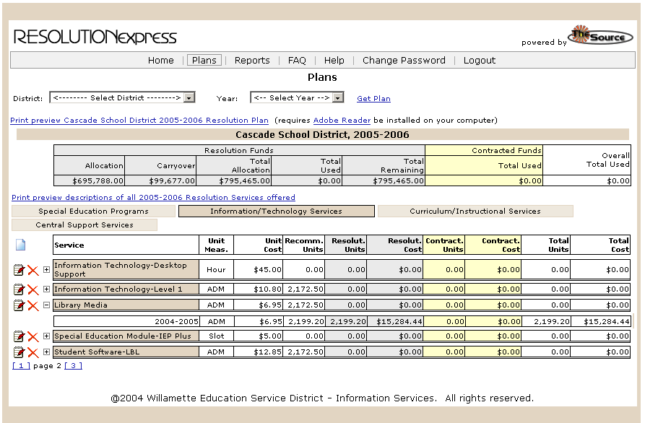
This table displays summary information for the Resolution Plan currently being accessed.
Click this link to view a PDF report of the Resolution Plan. You will need to have Adobe Reader installed on your computer in order to open and view PDF files. Click on the Adobe Reader link to download this free software from Adobe’s website.
Click this link to view a report showing all Resolution Services offered during the year of the plan.
Click on the page links to move from page to page.
Click on a department tab to view services provided by that department
Click the Expand History button to view prior year data for this service.
Once you click “Get Plan” the chosen Resolution Plan is displayed as shown above. You will see a table displaying real-time summary information for the plan. This summary information includes:
- Allocation: Amount of Resolution funds allocated for the year of the plan.
- Carryover: Amount of Resolution funds available from previous years.
- Total Allocation: Allocation plus Carryover.
- Resolution - Total Used: Total Amount of Resolution funds used on the plan.
- Total Remaining: Total Allocation minus Total Used.
- Contracted - Total Used: Amount of Contracted funds used on the plan.
- Overall Total Used: Total Amount of Resolution funds and Contracted funds used on the plan.

At this screen you can generate a PDF report of the Resolution Plan. You can also generate a report showing all Resolution Services offered during the year of the plan. If you are a District Primary level user then here you will also be able to make changes to the plan, as shown in the next screen shot, but if you are a District Team Level user you will only have read-level access to the plan.

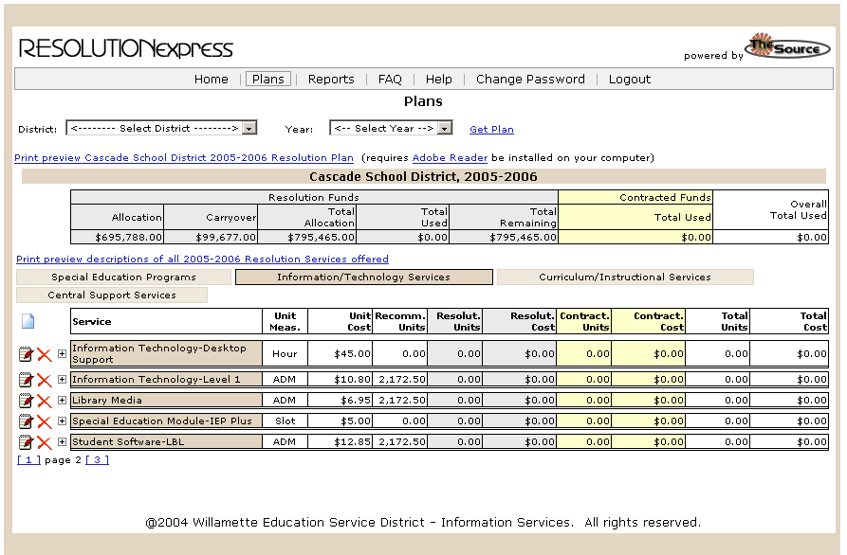
If you are a District Primary user then you can make changes to your district’s plan. Click the Edit button () to make changes to the service. Click the Delete button () to remove a service from the plan. Click the New Service button () to add a new service to the plan.
Click on the Edit button () to make changes to the service.
Click on the Delete button () to remove a service from the plan.

Click on the New Service button () to add a new service to the plan.
Note: If you remove a service from the plan you can add it back by clicking the New Service button (). The information previously saved will be restored when the service is added back to the plan.

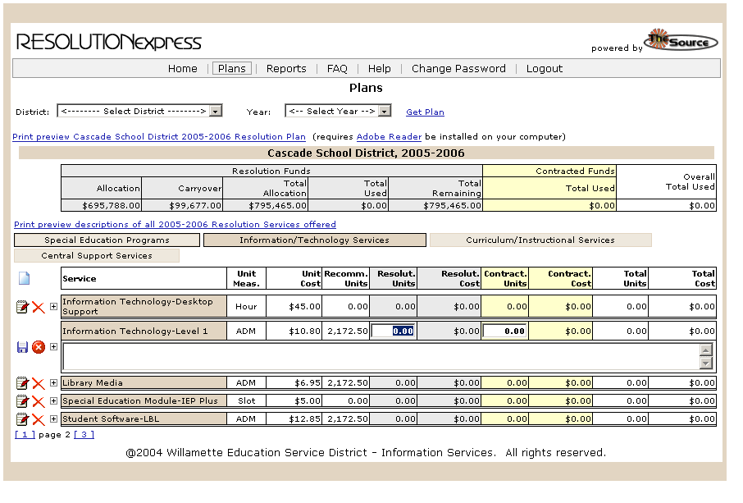
Click on the Save button () to save your changes to the plan.
Click on the Cancel button () to cancel changes to the service.
Enter number of Resolution Units purchased of this service.
Enter number of Contracted Units purchased of this service.
Enter the number of Resolution and Contracted units purchased of this service then
click the Save button () to save your changes. Click the Cancel button () to cancel the changes.

